Friday the 27th august, 2021
Time | Programme | Moderator
07:00 – 08:30 | Breakfast
08:30 – 08:40 | Programme and introduction to the day | Senior Lecturer, PhD Fellow Kitt Vestergaard
08:40 – 09:55 | Theme: Clinical leadership in a nursing context
08:40 – 09:10 | Clinical leadership and transitions seen in a historical perspective with Holbæk Hospital as case | Senior Lecturer, Dr. Lisbeth Aaskov Falch
09:10 – 09:25 | International perspectives and on clinical leadership for nurses | Dr. Gerry Lee, Reader in Advanced Clinical Practice, Kings College London
09:25 – 09:45 | Clinical leadership, practice and transitions for patients | Kitt Vestergaard
09:45 – 09:55 | Introduction to workshops | Kitt Vestergaard
09:55 – 10:15 | Break
10:15 – 12:25 | Workshop: Clinical leadership and transitions
10:15 – 11:15 | How do we incorporate clinical leadership and transitions at University College Absalon and our partners e.g., in the CCC project | Kitt Vestergaard
11.15 – 11.25 | Break
11.25 – 12.00 | Joined discussion: Towards an understanding of clinical leadership and transitions within University College Absalon | Kitt Vestergaard
12.00 – 12.25 | Reflections on the day and future perspectives on research incorporating partners | Docent Jesper Frederiksen
12.25 – 12.30 | Closure | Christina Louise Lindhardt
12.30 – 13.00 | Lunch

CHANGING CANCER CARE (CCC)
Workshop

From Research-based curriculum development to generating knowledge on Clinical Leadership in nursing
PROGRAMME
26. – 27. august 2021
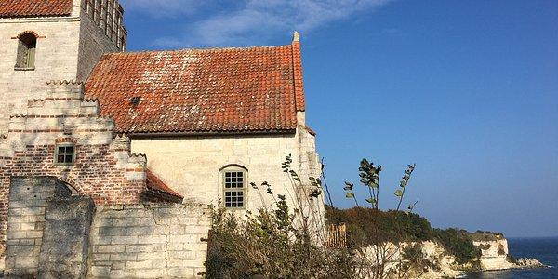
Rødvig kro og strandhotel, Østersøvej 8, 4673 Rødvig

Thursday the 26th august, 2021

Time | Programme | Moderator
09:00 – 10:00 | Arrival & Coffee
10:00 – 10:15 | Welcome | Dr. Christina Louise Lindhardt
10:15 – 11:00 | Theme: Changing Cancer Care – Interreg Research project
10:15 – 10:30 | Changing Cancer Care: An EU A Cross border research project | Mr. Keld Hundewadt
10:30 – 10:45 | CCC WP 3: Introduction and status on involving of nursing research in the project | Christina Louise Lindhardt
10:45 – 11:00 | Discussion and questions to the panel | Keld Hundewadt,  Christina Louise Lindhardt
11:00 – 11:10 | Break
11:10 – 14:15 | Workshop: Curriculum Development – how did we get there?
11:10 – 12:15 | Research-based development of a curriculum | Lecturer Pernille Brandt Smith  Senior Lecturer Anna Holm Jacobsen  Senior Lecturer Mette West Gajhede  Senior Lecturer Dr. Jette Mebrouk
12:15 – 13:15 | Lunch
13:15 – 14:15 | Research based development of a curriculum in a Danish context | Christina Louise Lindhardt  Senior Lecturer, PhD Fellow Kitt Vestergaard  Mette West Gajhede
14:15 – 15:00 | International Perspectives and The Social media: How do we define our roles? | Mette West Gajhede  Jette Mebrouk

Time | Programme | Moderator
15:00 – 15:30 | Coffee
15:30 – 16:30 | Oncological Nursing in an international perspective
15:30 – 15:35 | A brief introduction to Germany in seen from a healthcare perspective | Senior Lecturer Gundula Bergstrøm
15:35 – 15:55 | Roles, tasks and challenges in oncology nursing: The German perspective | Research Assistant, Lecturer Frederike Lüth
15:55 – 16:15 | Roles, tasks and effects of specialized nursing cancer care: The international perspective | Professor, Dr. Katrin Balzer
16:15 – 16:30 | Discussion & questions to the panel | Frederike Lüth  Katrin Balzer  Gundula Bergstrøm
16:30 – 16:45 | Changing Cancer Care as a platform for development of knowledge, Clinical Leadership and patientology in the transition between education and research | Docent, Dr. Jesper Frederiksen
16:45 – 17:00 | Closure | Christina Louise Lindhardt
17:00 – 19:00 | Break – go for a walk – relax – talk to your peers
19:00 – 21:00 | Dinner
21:00 | Coffee, networking

